
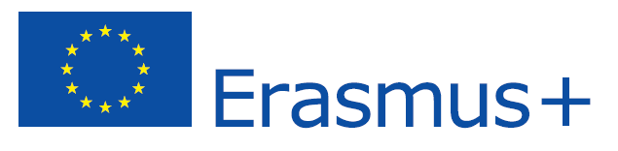

Erasmus Student Placement
EMPLOYER INFORMATION
Name of organization | NONA d.o.o.
Address | BRANITELJA DUBROVNIKA 15
Postal Code | 20000
City | DUBROVNIK
Telephone | ++385 20 640 557 ++ 385 99 213 9888
Fax | ++ 385 20 640 559
E-mail | davor.busnja@gmail.com
Website
Number of employees | 3
Short Description of the Company / HEI | Inovative architectural practice based in Dubrovnik and Zagreb. Multidisciplinary approach and large number of habitual collaborators of different professional profile ensure our sucesfull engagement with all dimensions of architectural and urban design. All projects are informed by a sensitive approach to place, the experiential potential of materials and construction and a concern for the environmental, social and economic aspects of sustainability. The practice is committed to a research-based approach, which is supported by the partners’ academic work and their participation in architectural competitions and juries, and aspires to create an architecture that is contemporary and rooted in its context, at all scales.
Other

CONTACT DETAILS
Contact person | DAVOR BUSNJA
Department / Function | ARCHITECT / PARTNER
Direct telephone number | ++ 385 20 640 557
Direct mobile | ++ 385 99 213 9888
Direct e-mail address | davor.busnja@gmail.com

PLACEMENT INFORMATION
Department / Function | ARCHITECT
Description of activities | ARCHITECTURAL AND URBAN DESIGN
Duration | 2-12 MONTHS
Working hours / Weekly hours | 9.00-17.00 MON-FRI
City | DUBROVNIK
Help with finding Accommodation | Yes  No
Financial contribution | Yes €  No
Other

REQIUREMENTS
Oral and written language skills | English (level: )  German (level: )  Other (level: )
Computer skills | AUTOCAD 2D & 3D, PHOTOSHOP
Driver's license | Yes  No
Other | MODEL MAKING

